**Experiment No – 4**

**Aim :** Implement an application that creates an alert upon receiving a message.

# CODE:

import android.app.AlarmManager; import android.app.Notification;

import android.app.NotificationManager; import android.app.PendingIntent; import android.app.Service;

import android.content.Context; import android.content.Intent;

import android.content.SharedPreferences; import android.hardware.SensorEventListener; import android.os.Build;

import android.os.IBinder;

import java.text.NumberFormat; import java.util.Date;

import java.util.Locale;

public class SensorListener extends Service implements SensorEventListener { public final static int NOTIFICATION_ID = 1;

private static int steps;

private void showNotification() { if (Build.VERSION.SDK_INT >= 26) {

startForeground(NOTIFICATION_ID, getNotification(this));

} else if (getSharedPreferences("pedometer", Context.MODE_PRIVATE)

.getBoolean("notification", true)) { ((NotificationManager)

getSystemService(Context.NOTIFICATION_SERVICE))

.notify(NOTIFICATION_ID, getNotification(this));

}

}

@Override

public IBinder onBind(final Intent intent) { return null;

}

@Override

public int onStartCommand(final Intent intent, int flags, int startId) {

// restart service every hour to save the current step count long nextUpdate = Math.min(Util.getTomorrow(),

System.currentTimeMillis() + AlarmManager.INTERVAL_HOUR); if (BuildConfig.DEBUG) Logger.log("next update: " + new

Date(nextUpdate).toLocaleString()); AlarmManager am =

(AlarmManager) getApplicationContext().getSystemService(Context.ALARM_SERVICE);

PendingIntent pi = PendingIntent

.getService(getApplicationContext(), 2, new Intent(this, SensorListener.class),

PendingIntent.FLAG_UPDATE_CURRENT); if (Build.VERSION.SDK_INT >= 23) {

API23Wrapper.setAlarmWhileIdle(am, AlarmManager.RTC, nextUpdate, pi);

} else {

am.set(AlarmManager.RTC, nextUpdate, pi);

}

return START_STICKY;

}

public static Notification getNotification(final Context context) { if (BuildConfig.DEBUG) Logger.log("getNotification"); SharedPreferences prefs = context.getSharedPreferences("pedometer",

Context.MODE_PRIVATE);

int goal = prefs.getInt("goal", 10000); Database db = Database.getInstance(context);

int today_offset = db.getSteps(Util.getToday()); if (steps == 0)

steps = db.getCurrentSteps(); // use saved value if we haven't anything better

db.close();

Notification.Builder notificationBuilder = Build.VERSION.SDK_INT >= 26 ?

API26Wrapper.getNotificationBuilder(context) :

new Notification.Builder(context);

NumberFormat format = NumberFormat.getInstance(Locale.getDefault()); notificationBuilder.setProgress(goal, today_offset + steps,

false).setContentText(

today_offset + steps >= goal ?

context.getString(R.string.goal_reached_notification, format.format((today_offset + steps))) :

context.getString(R.string.notification_text, format.format((goal - today_offset -

steps)))).setContentTitle(

format.format(today_offset + steps) + " " + context.getString(R.string.steps));

return notificationBuilder.build();

}

}

# OUTPUT:

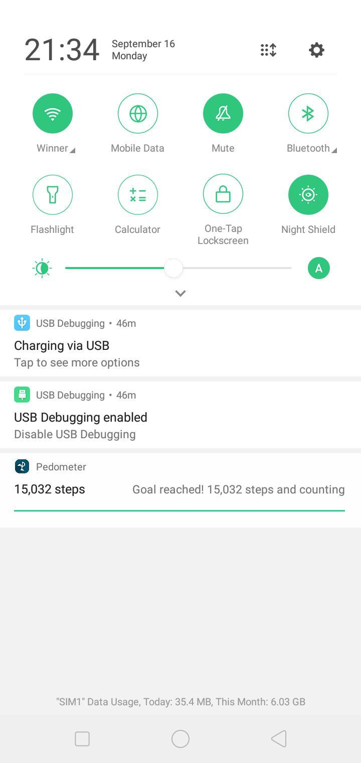

Output when Goal Steps are complete.

**Conclusion :**

We have successfully created an android application in android which shows alert when a goal state of steps have been walked.